Monthly Status Report – June 2026
Millbrook Solar & Storage
Liam McAllister · 03 July 2026 · MB-PM-RPT-202606
Area | RAG | Comment
Overall | Green | Planning application MDC/2026/0412 was submitted on 18 June with 27 supporting documents.
Cost | Green | Development spend EUR 2.21 m of EUR 3.10 m budget (71 %)
Schedule | Amber | Planning decision Q1 2027 – on track
Stakeholders | Green | Consultations held: 2 of 3

Summary
Planning application MDC/2026/0412 was submitted on 18 June with 27 supporting documents. The breeding bird survey finished on 26 June with 23 skylark territories.

Key figures
Metric | Value
Capex estimate (P50) | EUR 78.0 m
Open risks | 17
Consultation responses to date | 299
Development spend to date | EUR 2.21 m

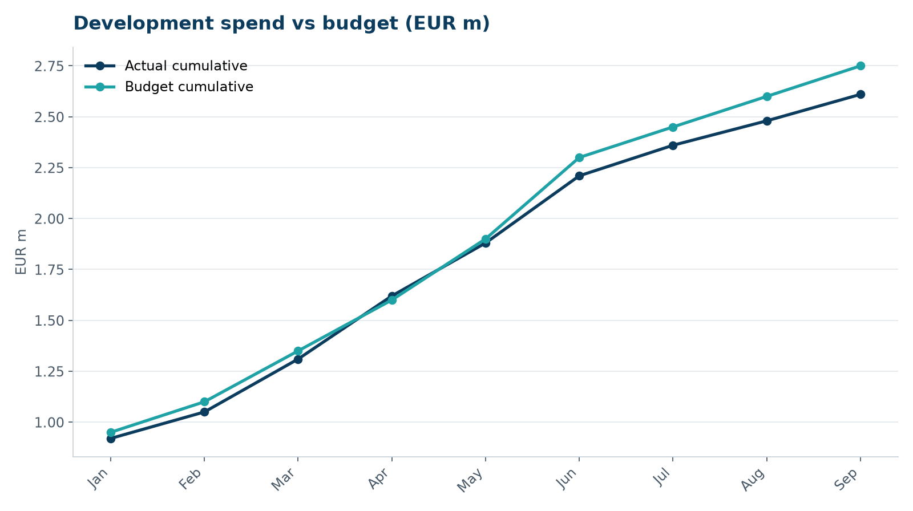
Development spend vs budget

Next month
- Support validation
- Lease variation for skylark plots
- Receive EPC bids (10 July)

